Views - Assignment 11
1) Create a view that shows all of the customers who have the highest ratings.
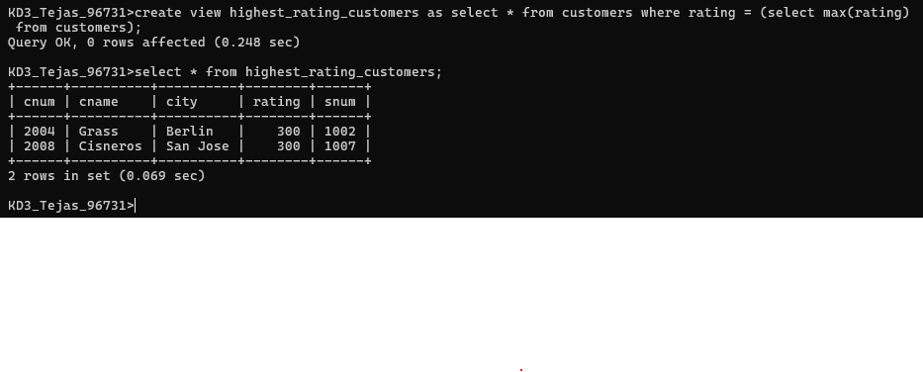
2) Create a view that shows the number of salespeople in each city.
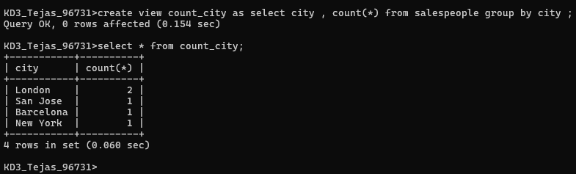

3) Create a view that shows the average and total orders for each salesperson after his or her name. Assume all names are unique.
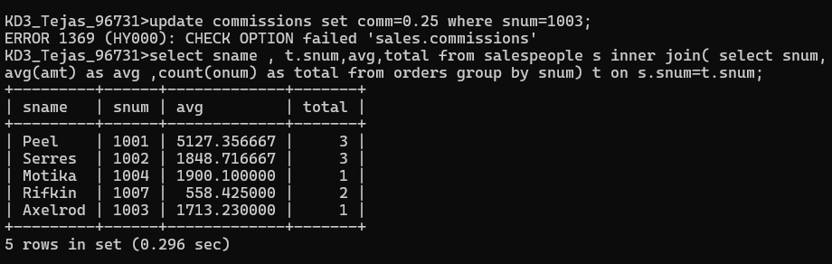

4) Create a view that shows each salesperson with multiple customers.
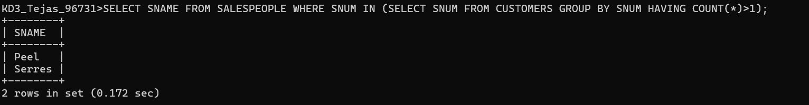

5) Which of these views are updateable (will allow DML operations)?
#1 Create View Dailyorders as Select Distinct cnum, snum, onum, odate from Orders;
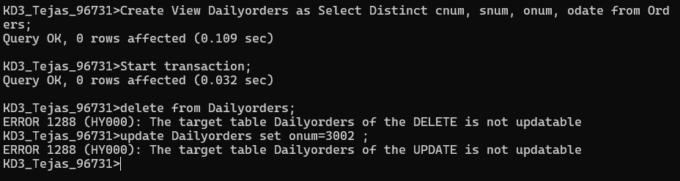
#2 Create View Custotals as Select cname, Sum (amt) Sum_Amt from Orders, Customers where Orders.cnum=Customers.cnum Group by cname;
- Not perform DML operation on this view because this is complex view .
#3 Create view Thirdorders as Select * from Dailyorders where odate=’1990-10-03’;
- Yes we can perform dml operation because this is simplex view.

#4 Create view Nullcities as Select snum, sname, city from Salespeople where city is NULL OR sname BETWEEN ‘A’ and ‘MZ’;
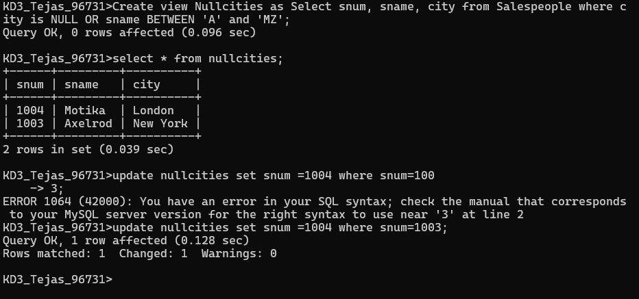
6) Create a view of the Salespeople table called Commissions. This view will include only the snum and comm fields. Through this view, someone could enter or change commissions, but only to values between .10 and .20.

